Selected games from 5lin

Games discussed by Ando Meritee.

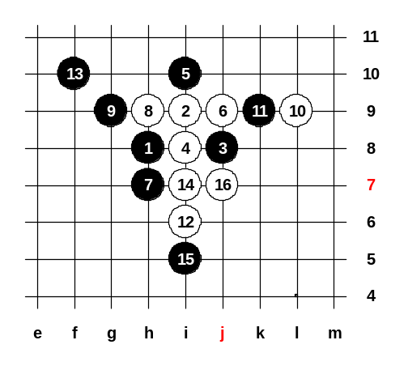
●Hongy(認輸) 對 ○琳兒(開局) →
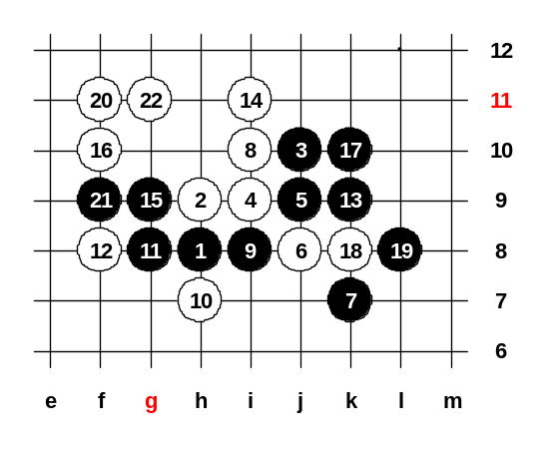
The opening i3 is very powerful for black. In serious tournaments people seldom use this opening. 琳兒 chose an active 6th move by making two white pairs. However, this white tactics is not very useful if black knows the right steps. Black should play 7-k9 here and then black position is very strong. Hongy made mistake in 7th move and after that white wins directly. If 9-k9 then white will trap the forbidden 3x3 at point f10.

← ●阿鄭(開局,認輸) 對 ○琳兒
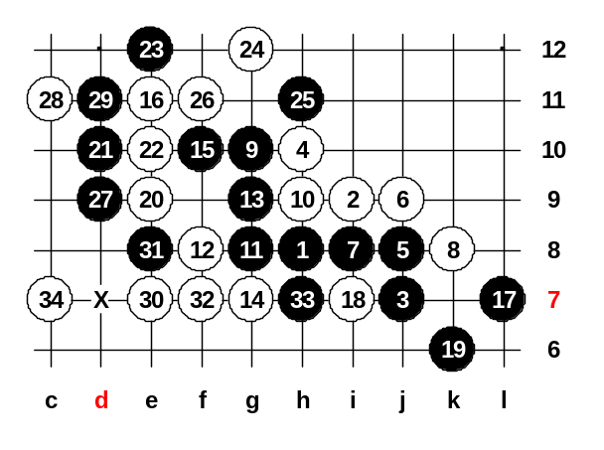
This variant of d3 opening is very popular recently. In generally, white should have an advantage after such 7th move. The 9th move is not good. White could play 10-g8, 12-h7 with the continuous advantage. But 琳兒 chose 10-h7 and after 11-g8, 12-f8 it becomes very complicated for both sides. Even now I am still not sure who has the advantage after 12-f8, black or white. However, the 17th move is not good one and white takes the control on the left side. Even though the 19th move was useless, there was no better defense either. White would have won anyway.

●u3170390 對 ○琳兒(獲勝) →
Amazing that white won that game. It should be black sure win opening. After the 5th move black is so powerful. With move 7 black began straight attack. Here is a lesson – if you do not see sure win, don’t begin straight attack with threes and fours, but continue building up the position first. In this game, 7-k9 is good preparation move. After that black will win easily no matter where white puts the 8th move, if 8-i7 then 9-k8. The end of the game was beautiful. White played good attacking moves 20, 22 and 24, provoking black to play 25-h11 and catching the forbidden 4x4 after that. Well done!
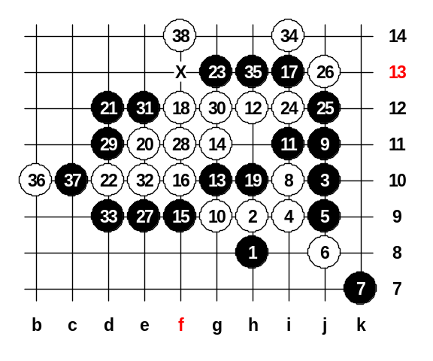
●chaos6145 對 ○沙織(開局,獲勝) →
Chaos6145 is a good renju player from China mainland. Usually he plays at Playsite.com. 沙織 is a young and talented female player from Taiwan. The famous opening was played in this game. The 9th move is quite interesting and popular. I thought the 10-i7 is the only possible choice for white. But 沙織 chose another 10th move, maybe not bad. I am surprised she found another interesting 10th move. After her 12th move black is very helpless. No matter how black would try to attack, white can control it. Finally, white self began attack and won with beautiful 4x4 trap. Maybe 11-i8 was better chance for black.
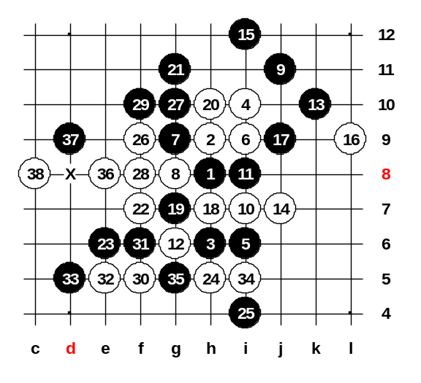
●chaos6145 對 ○finite555(開局,獲勝)
Finite is one of the members of our magazine team. He is also a good renju player. However, he in this game he tested another 16th move in the famous pattern of d11 opening. White attacked correctly all the way. The 21st was the mistake. But white made the mistake too, 24-h5. Now if black would play 25-c8 then white has no win anymore. Therefore, white should have played 24-f9 instead. If 21-j8 then 22-L8, 23-L7 and the further development is unclear. However, black will keep the advantage because white doesn’t have any win, that’s sure.

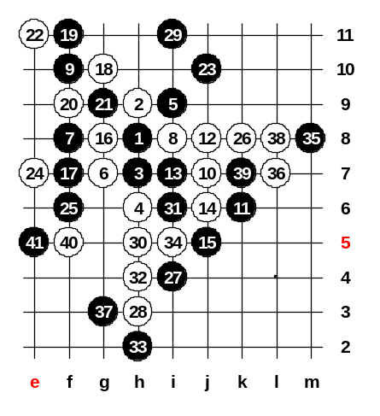
●chaos6145 對 ○iloy(開局,認輸)
The old classical variant. Books say many things about this pattern. The latest opinion about this patter is that black has better chances to win here. The 25th is the modern move, discovered by Russian players. The 26th is weak, it should be 26-g4 or h5, I think. White chose another style and made a mistake in attack and let black play first in the upper side. Of course black was too powerful after that and white had to resign. Iloy’s comment after game was – 30-i12.

●BigRock(開局) 對 ○takagawa(認輸)
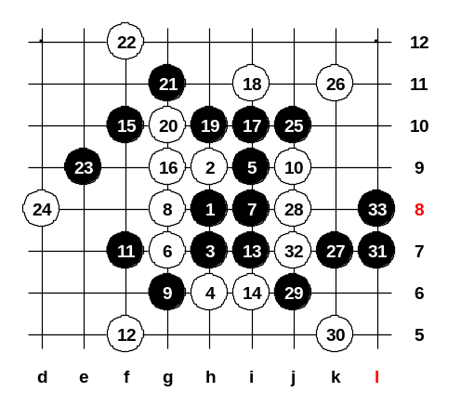
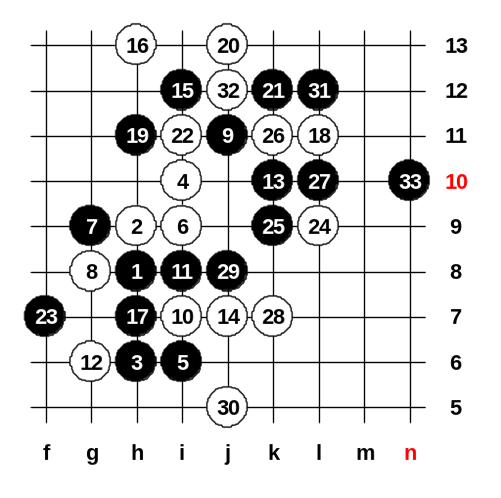
Bigrock chose the most active 7th move in d8 opening but in fact this move is very bad. White will control black attacking attempts very easily and surround black stones soon. The correct 7th move is 7-f8. You can find lots of theory about 7-f8 from any renju book. Perhaps the 8th move wasn’t the very best answer. In most cases, it is more useful to block the diagonal line. For example 8-g6 is very good! However, now after 8-g8 black had a chance to equalize the game. Bigrock continued with careful style now, see the moves 9 and 11. But suddenly he changed his style and became attack directly. As I have said before, direct attack is very bad if you do not find sure win. Since black has no sure win here, he should have continued with positional style, for example 13-i5, 14-i7, 15-j8, etc. By the 25th move black had got hopeless position. But white made a very bad 26th move. The 26-L10 was the best move, I think.

●kusajima(開局) 對 ○takagawa(認輸)
This is the standard pattern of modern renju theory.
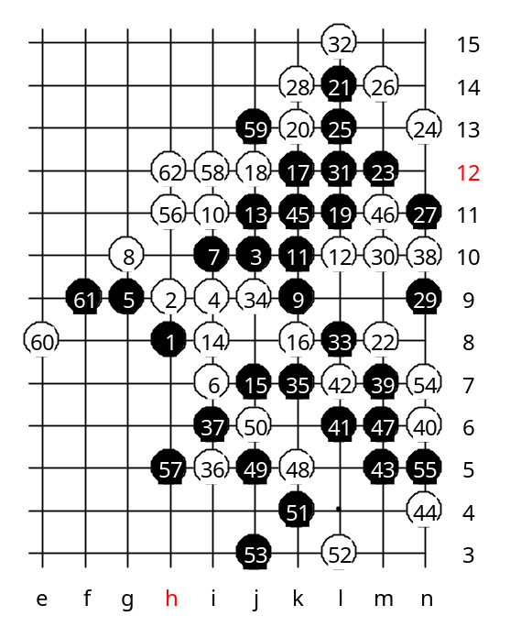
Until the 17th move most games in this opening go in same way. However, there are many different possibilities for 18th move. The 18-L11 was played in this game. It is not much analyzed yet, so we don’t know the very best move for black yet. My personal opinion is that 19-j5 is better than any other move in upper area. White played very well until he got sleepy and played lost 30th move.

●digiboy(認輸) 對 ○敗家淑女(開局)
D3 is my favourite opening at them moment, especially because it is very balanced opening, gives chances for both sides. In old times 9-i8 was popular, but that gave advantage to white. The new style 9-k9 was developed by Mr. Sagara, that gives advantage for black. The 11-i8 is better move than the 11th that was played in this game. 11 and 13 seem to be good attack, but if white defends correctly then black position becomes hopeless soon.

